Exercise 1 Look and write the missing letters.

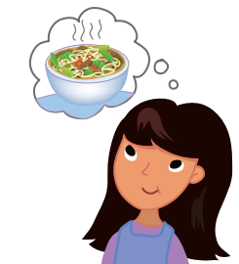

h _ _ gry

_ _ d

hap_ _

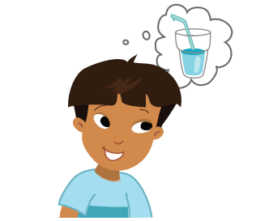

co _ _

h _ _

thirs _ _

Exercise 3 Circle the correct answer.

|  |  |  |
| --- | --- | --- |
| *1* | *2* | *3* |
| a. She is cold.  b. She is hot . | a. He is cold.  b. He is thirsty. | a. She is hungry.  b. She is hot . |
| *4* | *5* | *6* |
| a. She is sad.  b. She is happy. | a. He is cold.  b. He is hot. | a. He is sad.  b. He is happy |

Exercise 4 Look and write

|  |  |
| --- | --- |
| He | She |

|  |  |  |
| --- | --- | --- |
|  |  |  |
| a. ________ is sad. | c. ________ is happy. | e. ________ is cold. |
|  |  |  |
| b. ________ is thirsty. | d. ________ is hot. | f. ________ is hungry. |
| a. Yes , he is .  b. No , he isn’t. | a. Yes , she is .  b. No , she isn’t. | a. Yes , she is .  b. No , she isn’t. |

Exercise 7 Draw a face for each emotion.

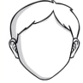 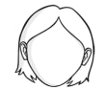 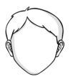

He is hot.

She is sad.

He is happy.

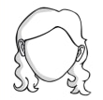 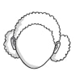 

She is thirsty.

She is cold.

She is hungry.

Exercise 10 Circle the correct answer.

|  |  |  |
| --- | --- | --- |
|  |  | Kết quả hình ảnh cho nose clipart |
| 1. man 2. mango | 1. apple 2. mango | 1. nose 2. neck |
| Kết quả hình ảnh cho neck clipart | Kết quả hình ảnh cho orange clipart | Kết quả hình ảnh cho octopus  clipart |
| 1. neck 2. face | 1. mango 2. orange | 1. orange 2. octopus |

Exercise 11 Look and match



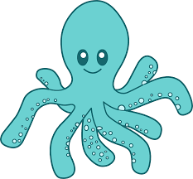

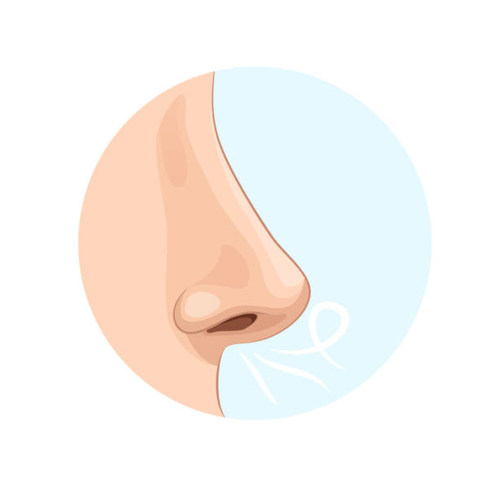

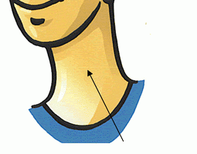

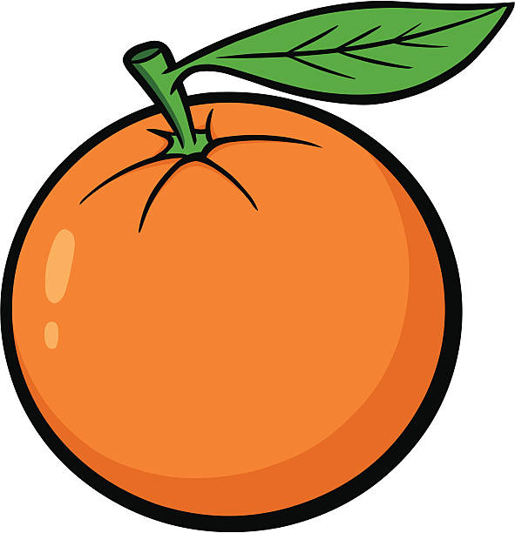



**Mm**

**Nn**

**Oo**